Assignment 1

Yunhan Zhang

|  |  |  |  |  |
| --- | --- | --- | --- | --- |
| Table | Type | Row Count | PK(s) Used | One Row Is |
| Employees | Master Data | 9 | EmployeeID | An employee |
| Employee Territories | Business Process | 49 | EmployeeID, TerritoryID | An employee assigned to a territory |
| Customers | Master Data | 91 | CustomerID | A customer |
| Suppliers | Master Data | 29 | SupplierID | A supplier |
| Products | Master Data | 77 | ProductID | A product |
| Shipments (of orders) | Master Data | 3 | CustomerID, ProductID, OrderID | A shipper |
| Details (of an order) | Business Process | 2155 | OrderID, ProductID | A product assigned to an order |

1. List the customer contact names and titles sorted by company name.

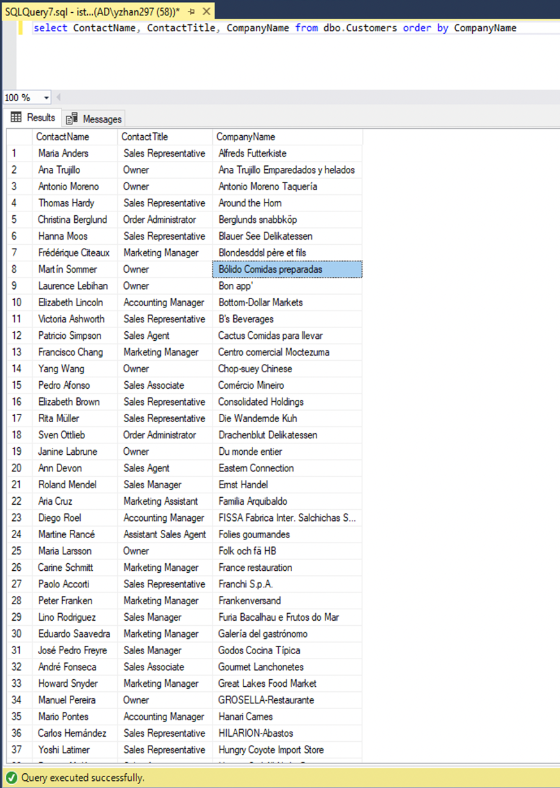

1. Factoring in discounts, what is total amount of product sold?

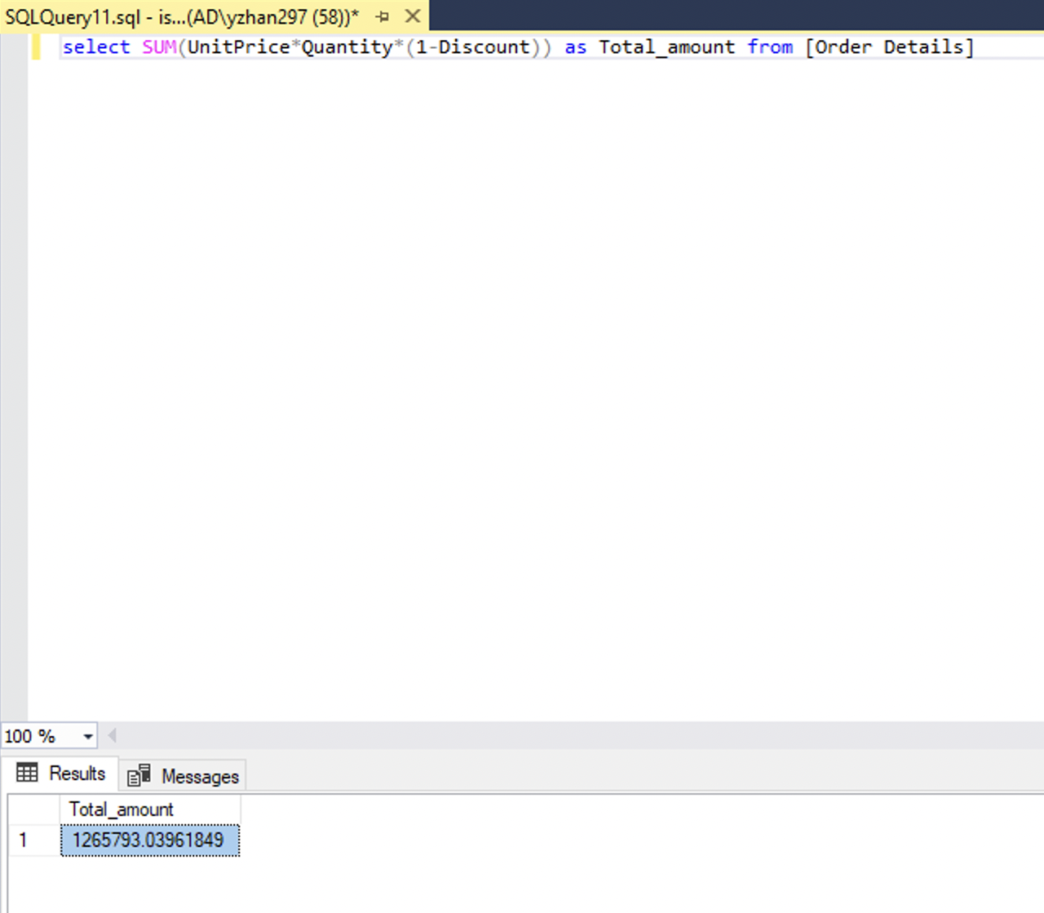

1. Provide a list of product category names with counts of products in each category.

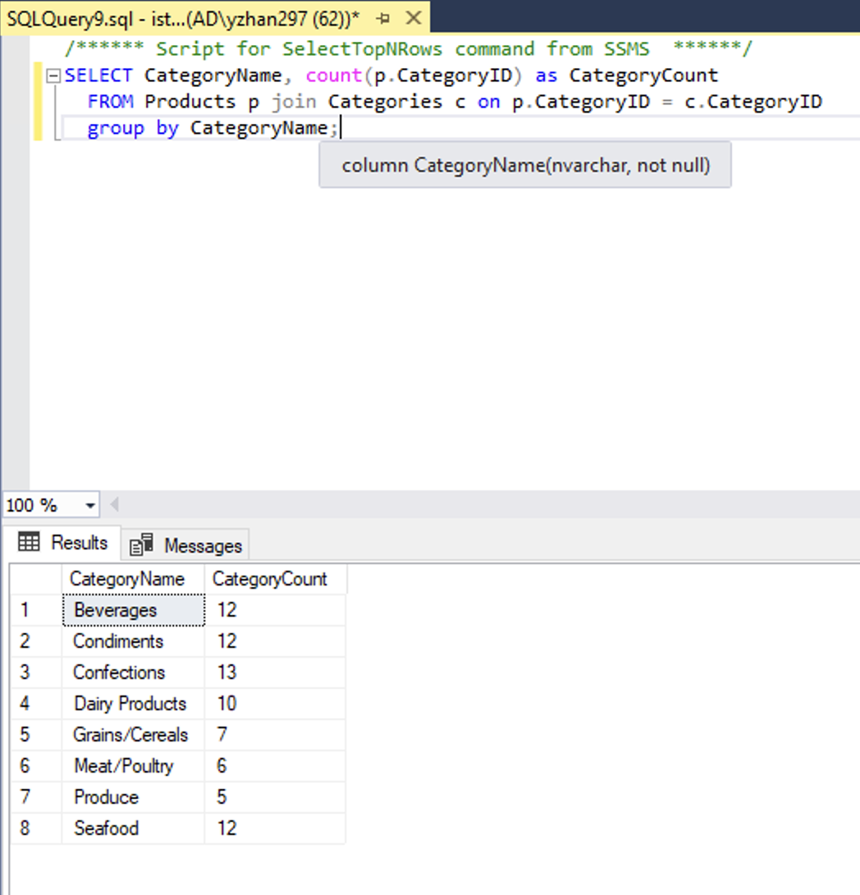

1. Select a specific customer, and display that customer’s orders with total amount of product sold for each order.

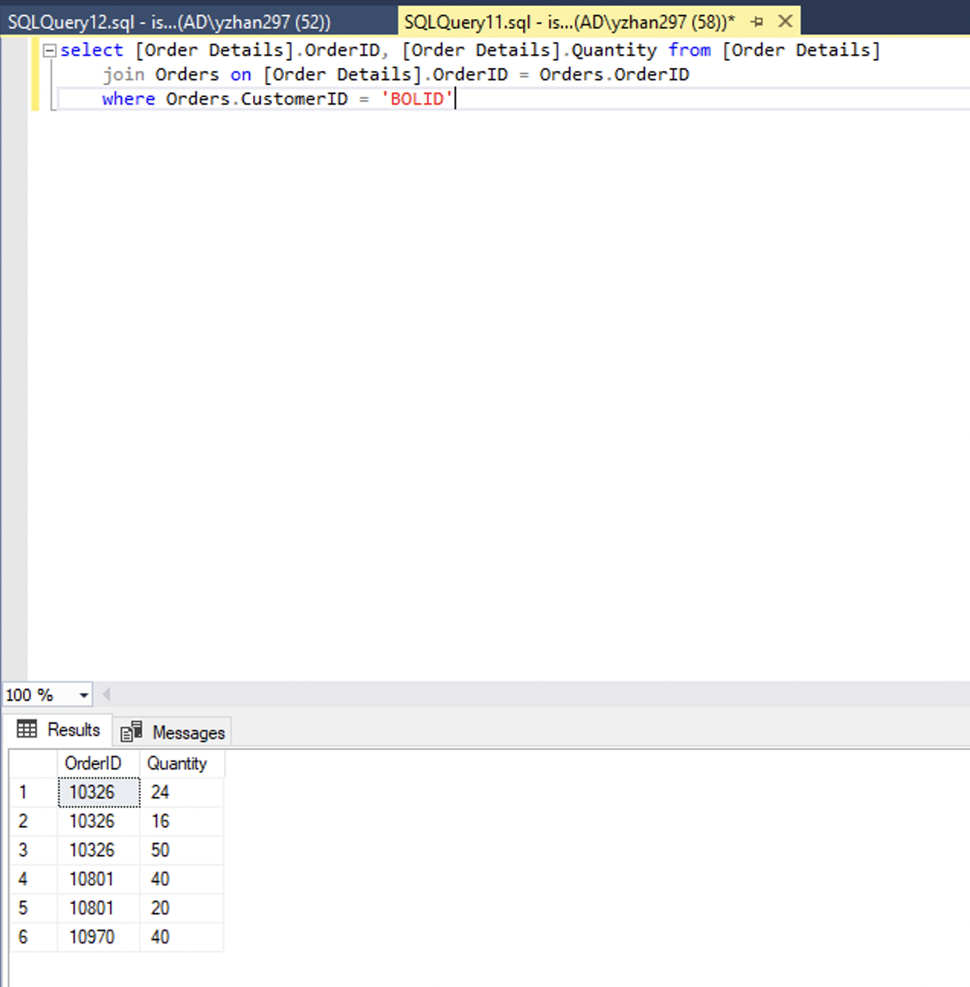

1. Select a specific employee and each order, how it was shipped (shipvia), the company who shipped it, and the total number of days elapsed from order date to shipped date.

